Control Systems Lab Name:___________________

Prelab 5: In Class Assignment RIN:____________Section:__
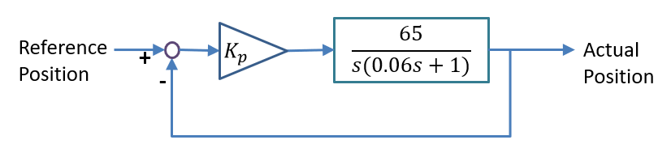
Consider control of DC motor position. The transfer function from voltage to position (in radians) of the motor is $G\left(s\right)= \frac{65}{s(0.06s+1)}$ . The block diagram shows closed loop control of the position with proportional gain, $K_{p}$.

- Obtain the closed-loop transfer function. Simplify the expression so that fractions are cleared as much as possible and the first term in the denominator is ‘s²’ (i.e. has a coefficient of 1).

- Design two different values for $K_{p}$: for critical damping (no overshoot), and for overshoot of 10%. Use the formula for damping ratio from transient response specifications: $ζ=\frac{-\ln\left(\%OS/100\right)}{\sqrt{\left(π^{2}+{\ln^{2}\left(\%OS/100\right)}\right)}}$

- Saturation: Recall that the voltage applied to the DC motor system in this lab is limited by the USB connection – assume 4.8 V maximum. What is the maximum proportional gain, K_{p}, that could be used that would not cause saturation of the input voltage for a step command of $θ_{desired}=1.5π$ when starting at a position of $θ=0?$

- Static Friction: Recall that if the voltage applied to the DC motor system is too small (less than about 0.7 V), motion will be prevented by static friction. For the smallest of the two gains computed in Question 2, what is the minimum error, ${(θ}_{desired}-θ),$ that the controller can respond to while still overcoming static friction?

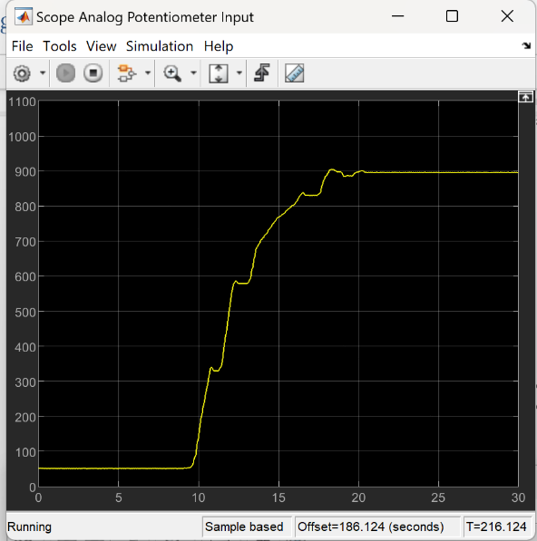
- Unit Conversion: In the lab, a potentiometer is used to set the reference position. The desired units are in radians, but the potentiometer outputs values in unknown units. An experiment is done where the potentiometer is moved one half of a rotation. The potentiometer reading changes from 100 potentiometer units to 800 potentiometer units. What is the factor to convert from potentiometer units to radians?

